# Components

## Finder

Handles lookup by Res #, Dates, Guest etc

## Reservation

Has Res Detail allowing update and checkin

# Routing

# CLI

## Project

Ng new kiosk --directory=kiosk --routing=true

## Component

Cd src\app\components

Ng generate component

# Messaging ala ExampleApp

## Model

Think “prompts”

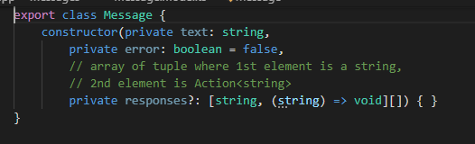

## Service

* Has a Subject<Message> - subject
* Allows publication – reportMessage()

## Component